Eng. Ali Abbas  
Developer at LIT Company  
Tel: +963 (0)938 015 781  
ali.abbas@lit-co.net  
LIT LTD Akkar, Lebanon

**AI Anonymization Project Report**

# **1) Overview:**

The General Data Protection Regulations (GDPR) enforces rules relating to the protection of natural persons with regards to the processing of personal data and rules relating to the free movement of personal data, to eventually protect fundamental rights and freedoms of natural persons and in particular their right to the protection of personal data.[1]

To comply with GDPR, companies have to redact information that expose personal details about individuals as stated in the GDPR manual, and these details include human faces and license plates.[2]

In that light, we think AI can do a great job in determining the position of such information in available data, so we planned a pipeline to pre-process the data using AI (i.e., automatically determining the location of face and/or license plates in an image.

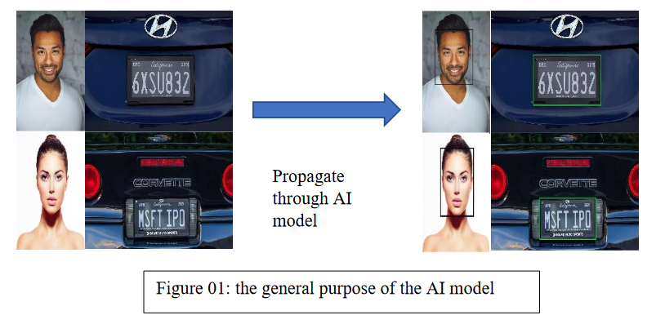

The report discusses the datasets used in the project in section 2, the project plan in the section 3, the plan details in article 3, subsection “a”, details of the progress and implementation in article 4, convergence graphs .

# 2) Datasets:

* CelebFaces Attributes Dataset (CelebA) is a large-scale face attributes dataset with more than 200K celebrity images, each with 40 attribute annotations. The images in this dataset cover large pose variations and background clutter. CelebA has large diversities, large quantities, and rich annotations, including 10,177 number of identities, 202,599 number of face images, and 5 landmark locations. The dataset can be employed as the training and test sets for various computer vision tasks such as face attribute recognition, face detection, landmark (or facial part) localization, and face editing & synthesis. [3]

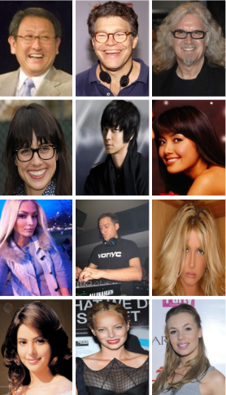

Figure 1: Sample from CelebA dataset

* The Chinese City Parking Dataset (CCPD) is a dataset for license plate detection and recognition. It contains over 250k unique car images, with license plate location annotations. The dataset can be used for training and testing computer vision models for license plate detection and recognition tasks.[4]

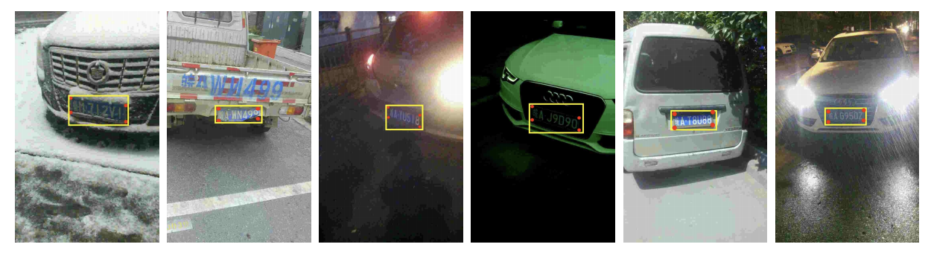

Figure 2: Sample of CCPD dataset

Figure 3: CelebA dataset sample

# **3) Project Plan:**

In order to get a model that can accurately annotate images that might or might not contain faces and/or license plates, the process involves the following steps:

1. Dataset(s) selection
2. Data preparation
3. Model selection
4. Training
5. Evaluation
6. Candidate Model Selection

a) **Plan Details**:

**Data set selection**:

Face Detection Dataset: CelebA (205999 annotated faces). [3]

License Plates Detection Dataset: Chinses City Parking Data (350k annotated license plates). [4]

**Data preparation**: Datasets are saved on Google Drive, the preparation pipeline goes as follows: download -> extract -> read -> decode (from papers instructions) -> convert to COCO Format -> save info as JSON files to be instantly registered upon training.

**Model Selection**: we fine-tuned 6 pre-trained checkpoints from detectron2’s model zoo, that are

**Training**: Training parameters is fixed amongst all 6 trials.

**Evaluation**: Evaluate the trained models on Average Precision (AP) metric.

**Model Selection**: select the mode with the highest AP.

4) **Implementation Details**:

**Environment Setup**:

Python 3.8

detectron2 0.6

PyTorch 1.8 (and corresponding packages like torchvision and torchaudio)

numpy (1.24.2)

matplotlib (3.7.1)

gdown (4.7.1).

**Dataset Selection**: datasets are available on Google Drive (links are in the data-related references).

**Dataset Preparation**: the accepted architecture of a dataset to be input to a detectron2 model is as follows: List[dict(1st instance info), dict(2nd instance info), …, dict(ith instance info)], data is extracted after downloading to a directory named raw, and then each dataset information is written to a JSON file in COCO format to be used later in the data registration.

**Selected Pre-Trained Checkpoints**: we choose the following (models/variations):

faster_rcnn_R_101_FPN_3x

faster_rcnn_R_50_DC5_3x

faster_rcnn_R_101_C4_3x

retinanet_R_50_FPN_3x

faster_rcnn_R_50_C4_3x

retinanet_R_101_FPN_3x

**Training**: the parameters are fixed through all the training experiment:

**learning rate**: 0.00025 (decay at the 30kth step by a factor of 0.7)

**number of steps**: 60k

**batch size**: 1

**Evaluation**: evaluate models used a subset of the datasets.

**Candidate Model Selection**: **faster_rcnn_R_50_C4_3x**

# **5) Final Step:**

Run training for the candidate model on a larger subset of the datasets (could be as large as 200k images per category and might take more than 5 days).

Execution of the final step can be done by running the following two commands

python src/prepare_data.py

python src/train.py --yaml_url COCO-Detection/faster_rcnn_R_50_C4_3x.yaml

The reason why I didn’t train all potential checkpoints on the larger dataset is that The execution time of the training task is directly proportional to both the size of the dataset and the number of epochs, with an increase in either resulting in a corresponding increase in execution time. So, instead of waiting for more than a month to get the results I decided to go with a greedy approach and take the model that shows the most potential from the first epoch on a dataset that is relatively sufficient.

# **6) Training Details:**

Training parameters:

* Batch size: 1 (down from 2 since some models failed on a batch size 2 under 512 ROI heads)
* ROI heads: 512 (up from 256 for better performance)
* Learning rate: 0.00025
* Learning Rate Decay Details: [Scheduler:: Step Decay, Decay Gamma: 0.7, Interval: 30k]
* Train size: 60, 000
* Test size: 10, 000
* Val size: 10, 000
* Number of steps: 60, 000 (1 epochs)
* Layers fine-tuned: all model layers (including backbones).
* Optimizer: Adam
* Evaluation Metric: Average Precision (AP)

|  |  |  |  |  |
| --- | --- | --- | --- | --- |
| Monitor  Model | Localization Loss | Classification Loss | Total Loss | Average Precision (AP) |
| faster_rcnn_R_101_FPN_3x | 0.0411 | 0.0168 | 0.0636 | 70.6 |
| faster_rcnn_R_50_DC5_3x | 0.0353 | 0.0114 | 0.0566 | 72.11 |
| faster_rcnn_R_101_C4_3x | 0.0373 | 0.0142 | 0.0744 | 71.76 |
| retinanet_R_50_FPN_3x | 0.153 | 0.0247 | 0.182 | 71.08 |
| faster_rcnn_R_50_C4_3x | **0.0332** | **0.0119** | **0.0789** | **75.72** |
| retinanet_R_101_FPN_3x | 0.126 | 0.0198 | 0.156 | 68.98 |

Table 1: Evaluation Summary

# **Loss Graphs for Trained Models**:

## faster_rcnn_R_101_FPN_3x:

Localisation Loss Graph

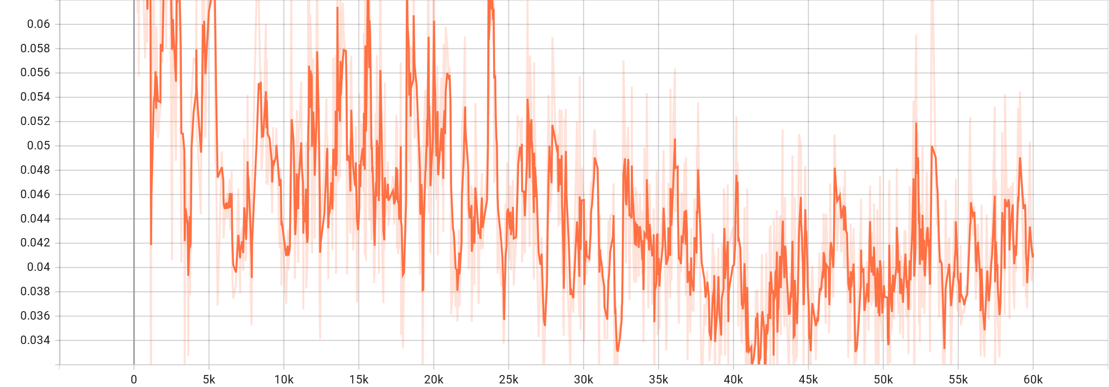

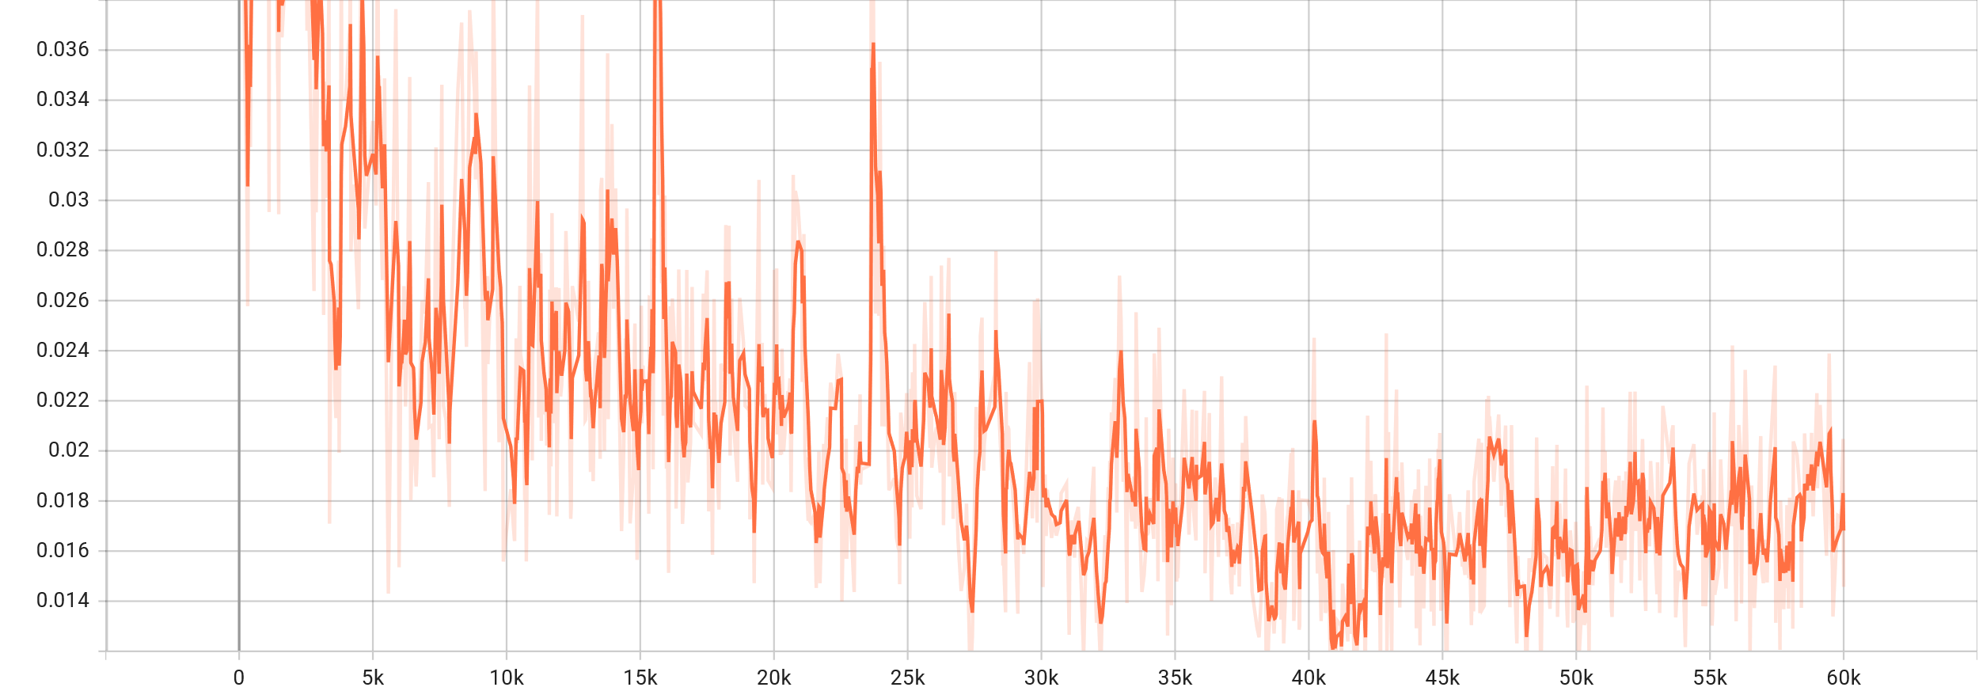Classification Loss:

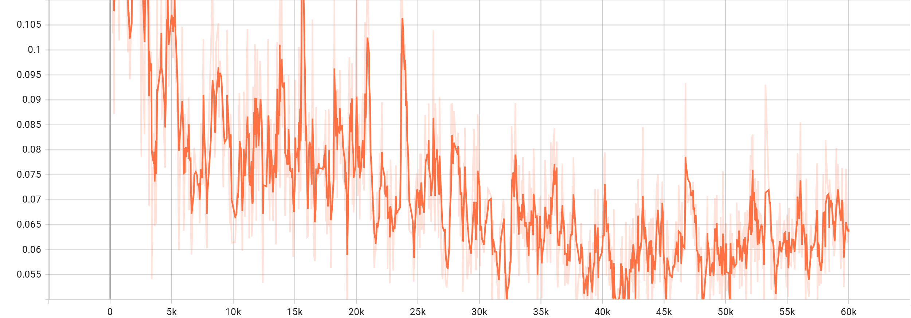Total Loss:

## faster_rcnn_R_50_DC5_3x:

Localisation Loss Graph

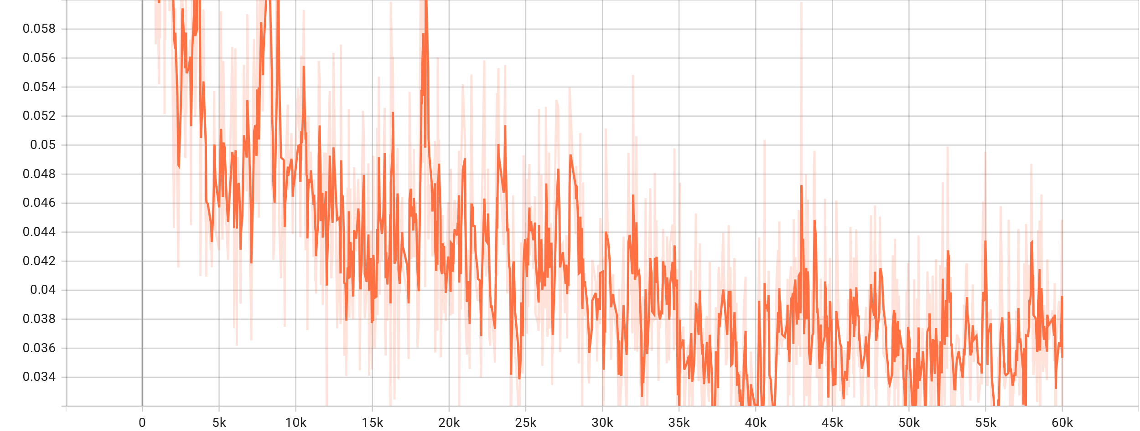

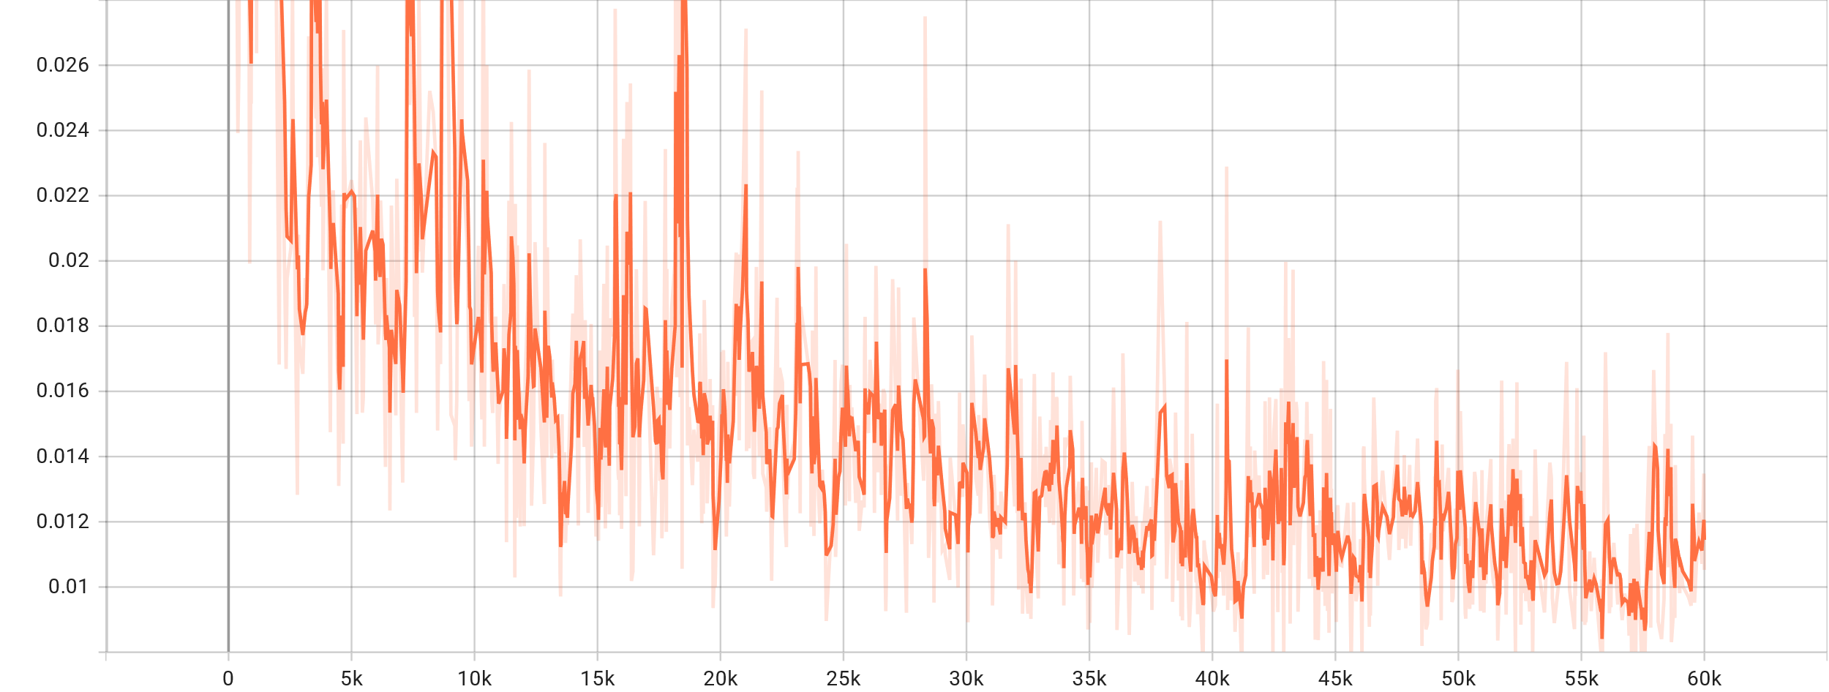Classification Loss:

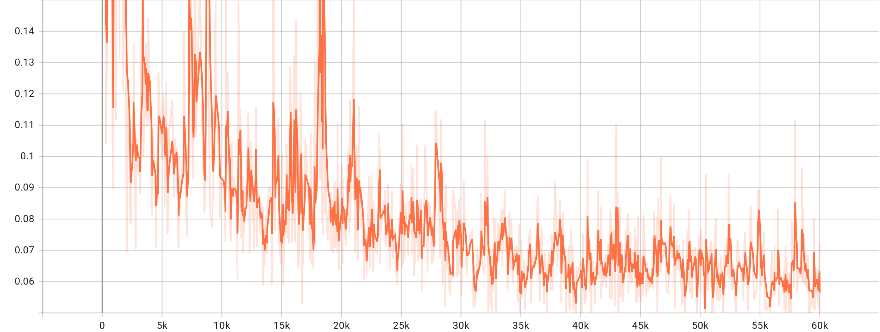Total Loss:

## faster_rcnn_R_101_C4_3x:

Localisation Loss Graph

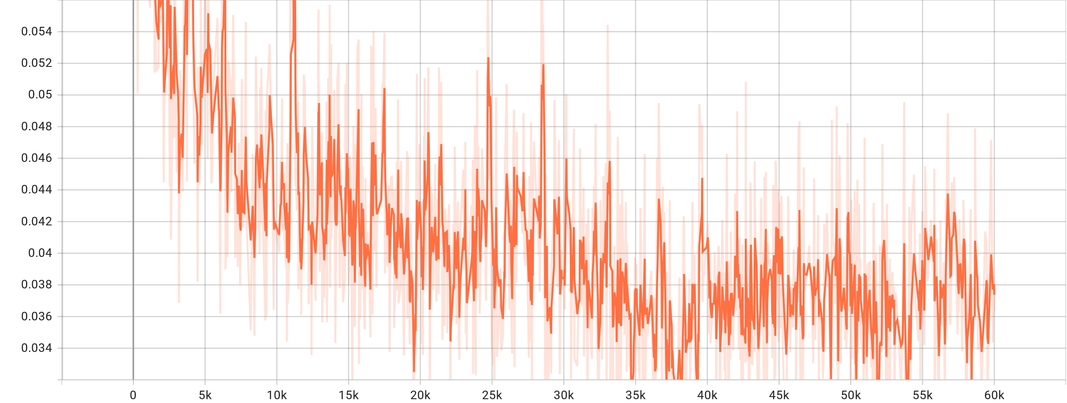

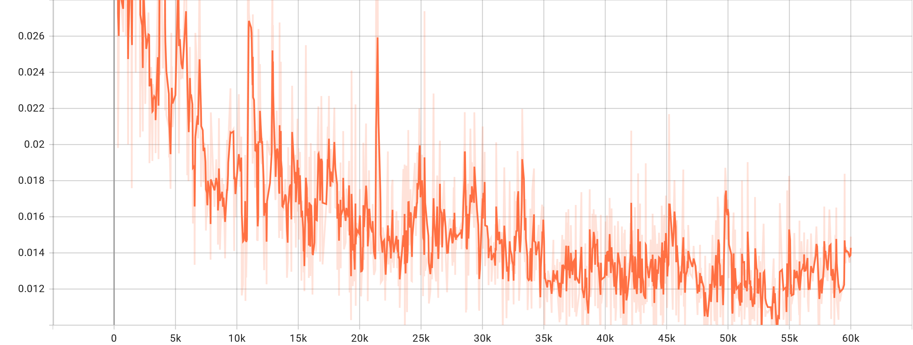Classification Loss:

Total Loss:

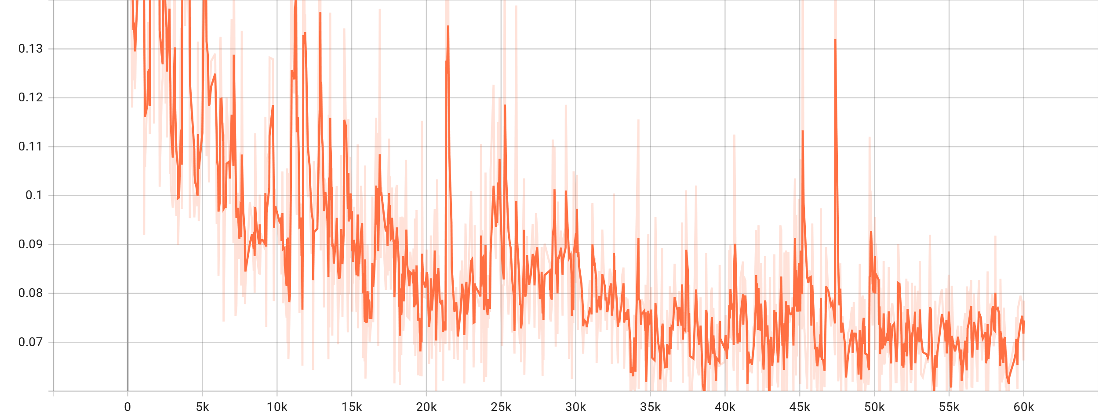

## retinanet_R_50_FPN_3x:

Localisation Loss Graph

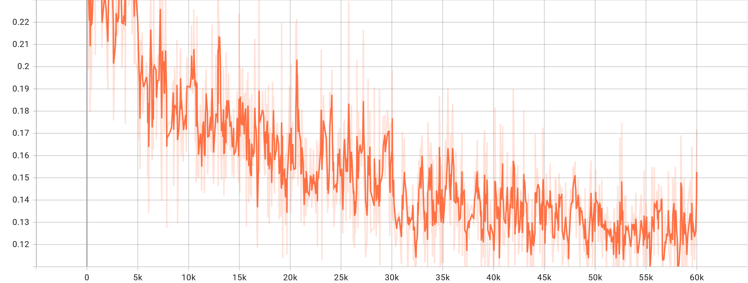

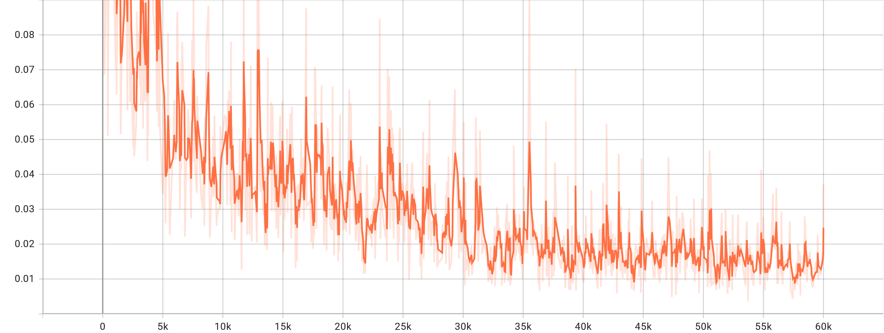Classification Loss:

Total Loss:

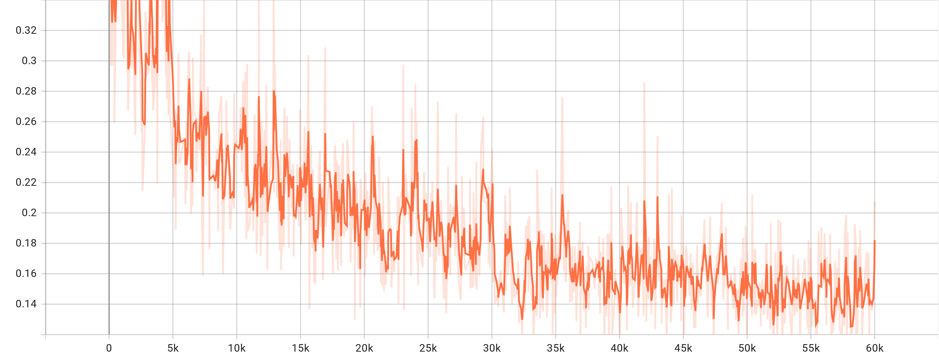

## faster_rcnn_R_50_C4_3x:

Localisation Loss Graph

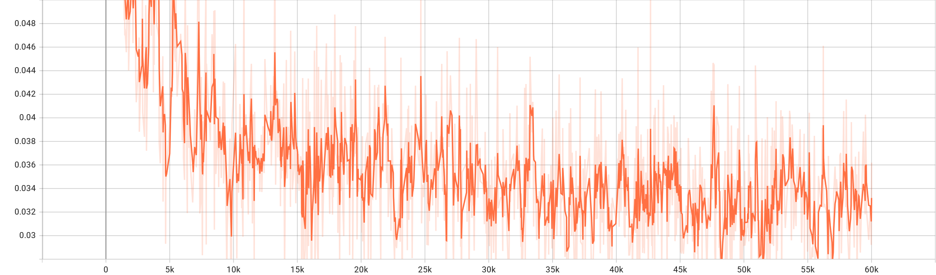

Classification Loss:

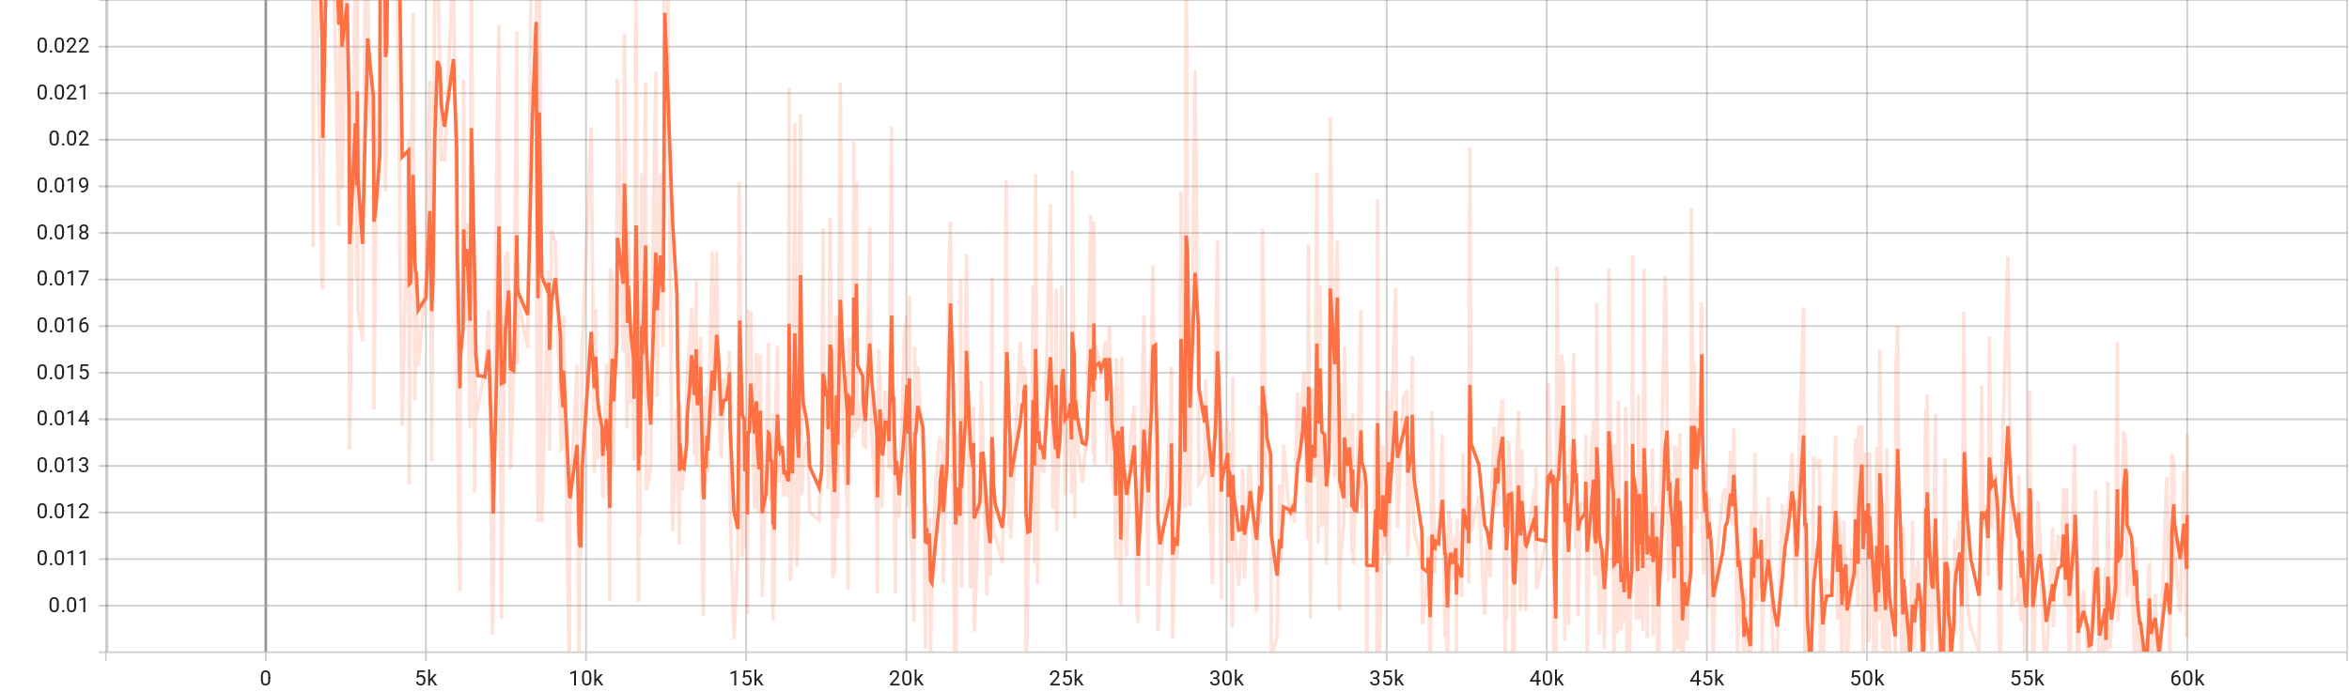

Total Loss:

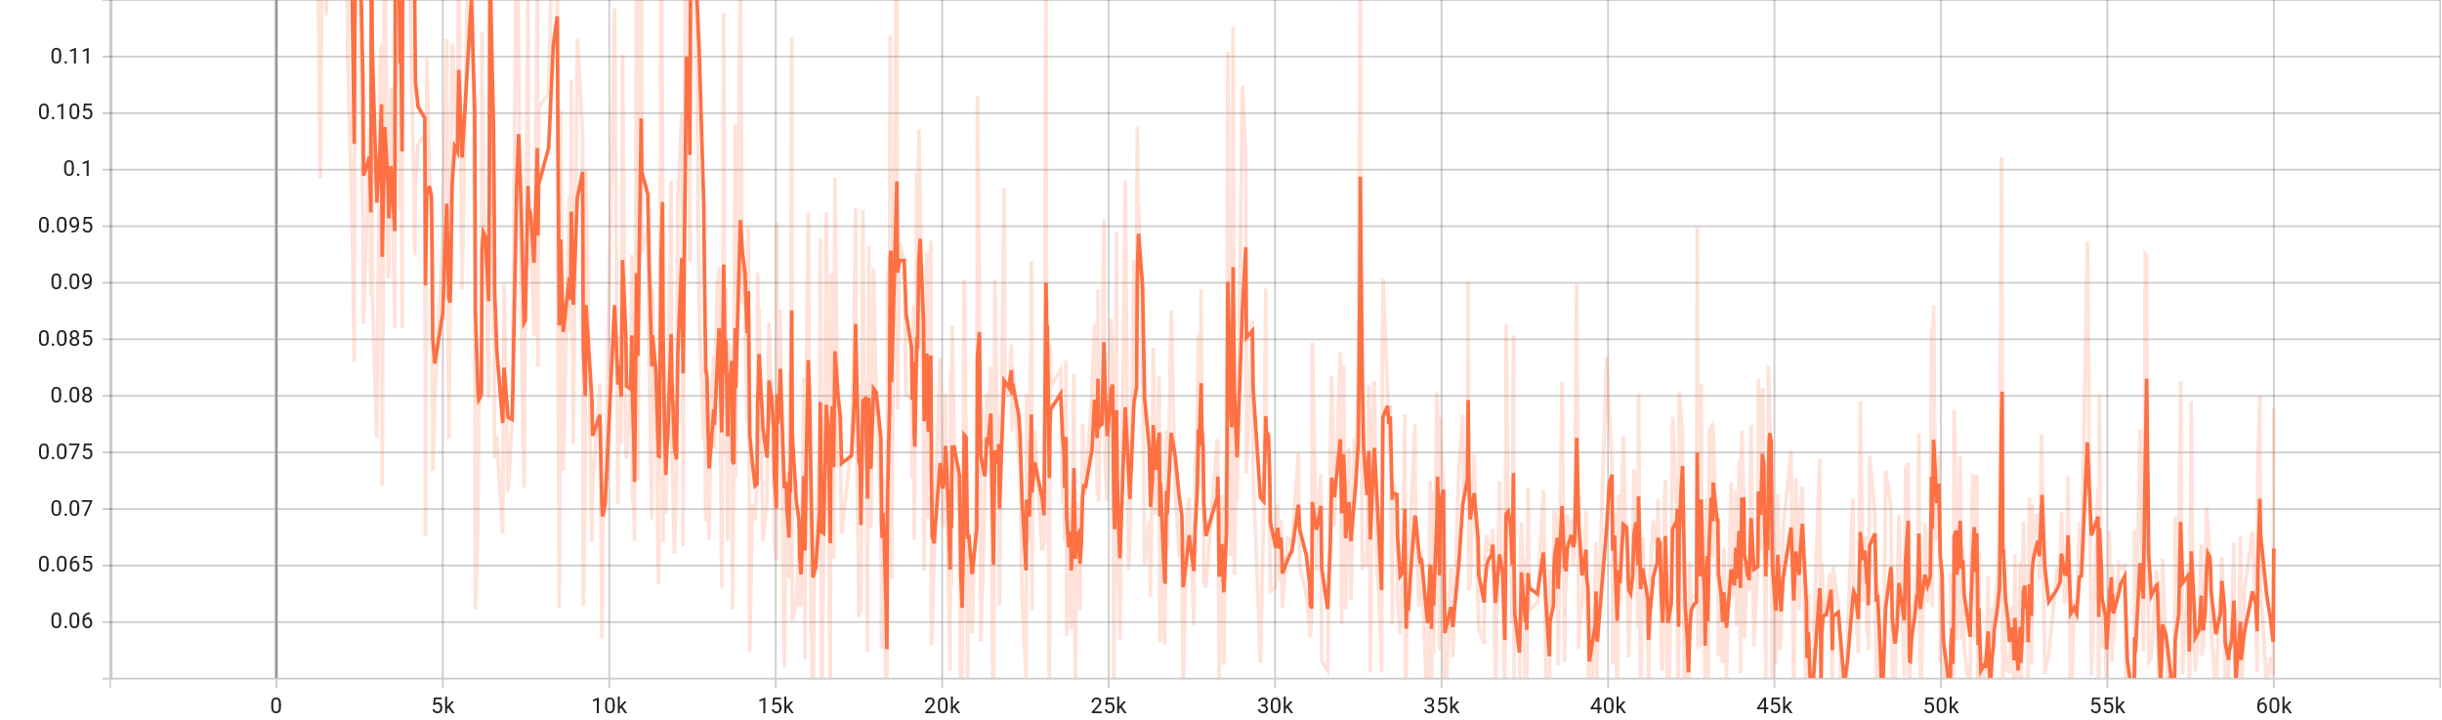

## retinanet_R_101_FPN_3x:

Localisation Loss Graph

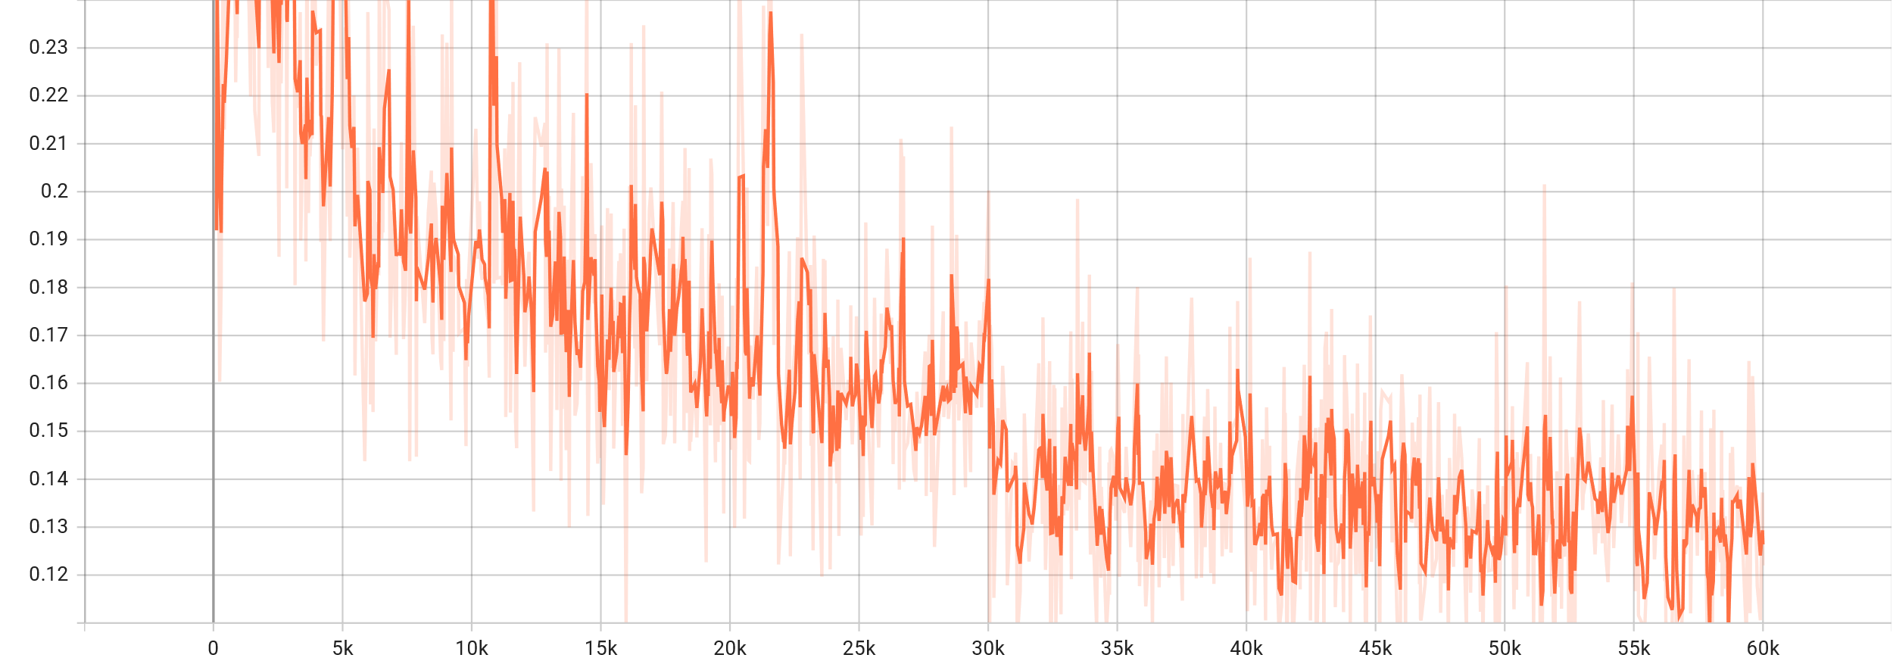

Classification Loss:

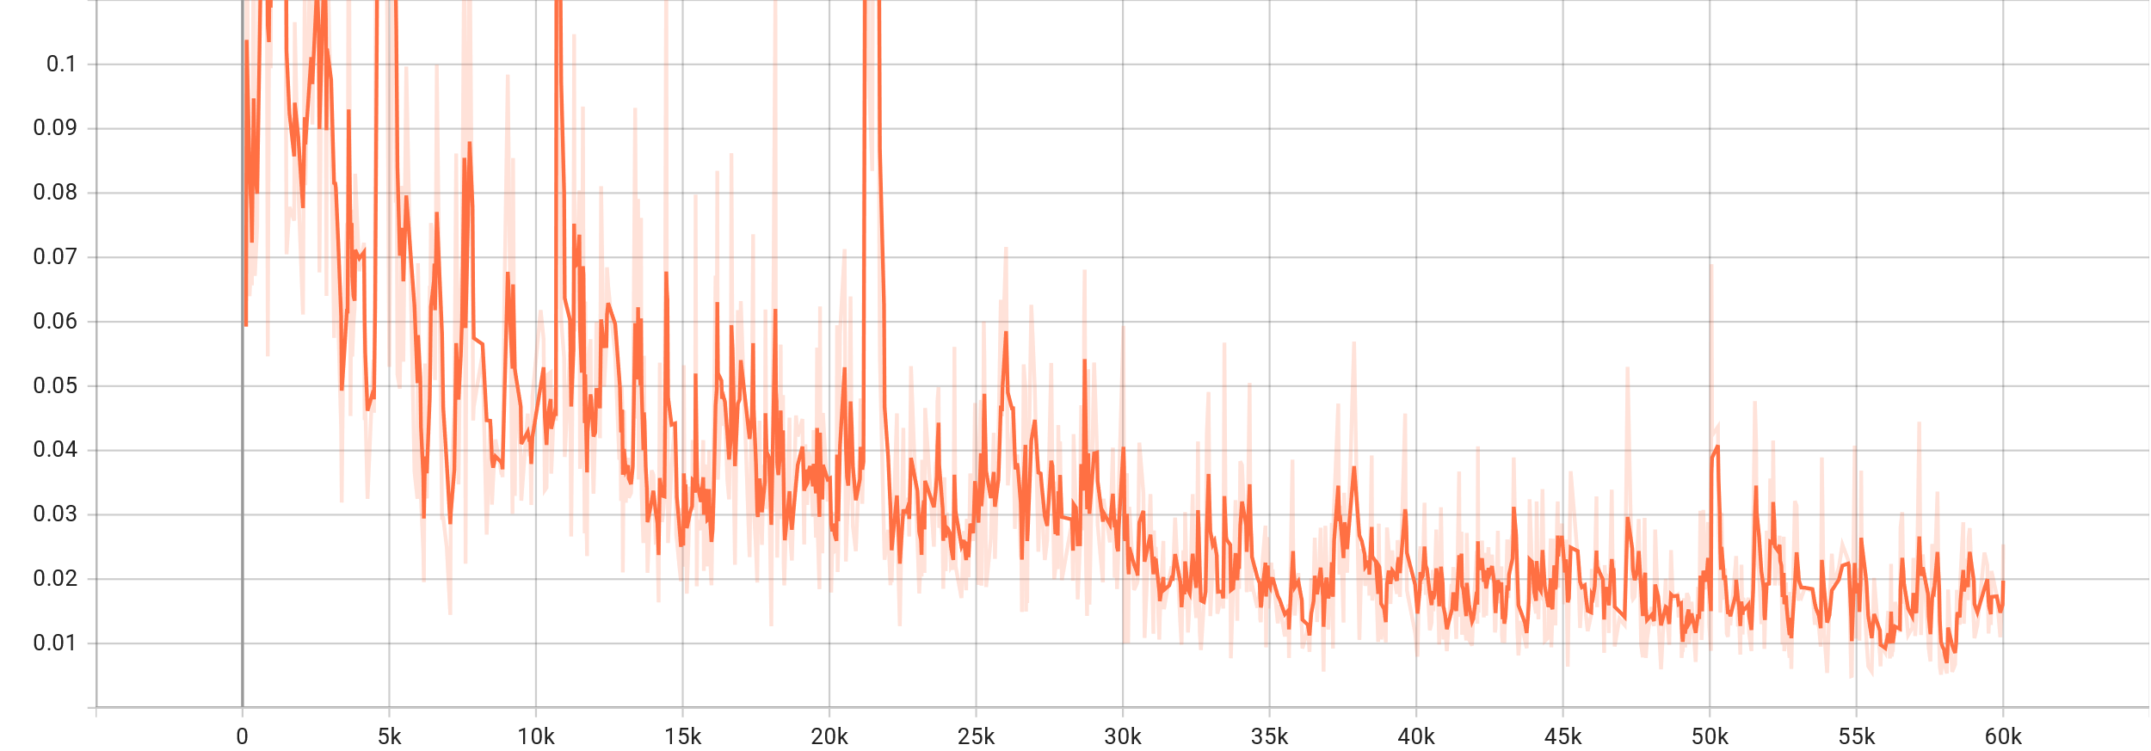

Total Loss:

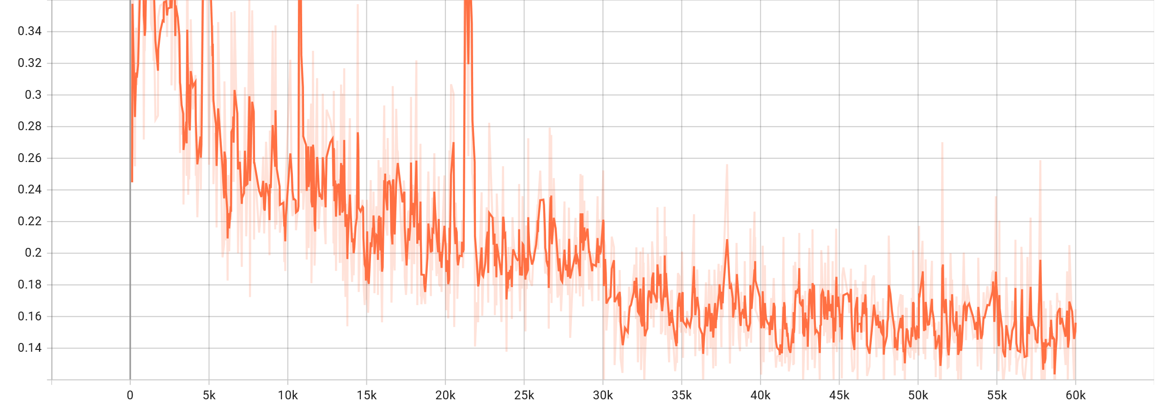

# **Sample prediction:**

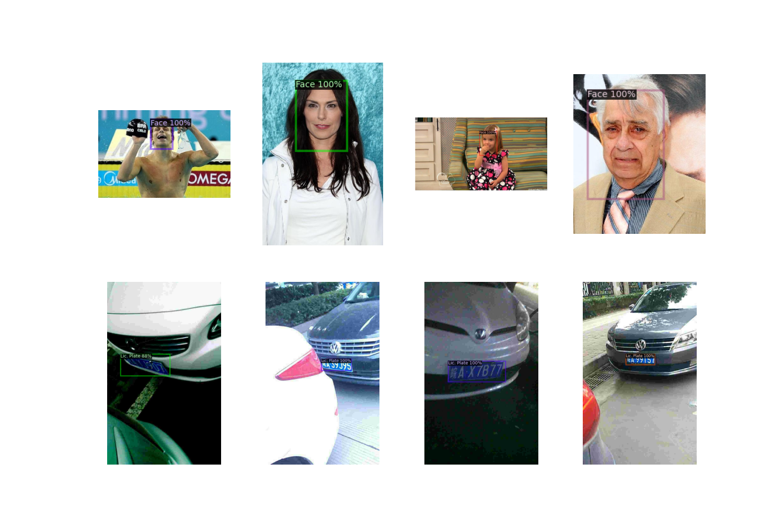

Figure 4: Sample of predicted annotations using faster_rcnn_R_50_C4_3x

# **5) References:**

1. [Art. 1 GDPR – Subject-matter and objectives - General Data Protection Regulation (GDPR) (gdpr-info.eu)](https://gdpr-info.eu/art-1-gdpr/)
2. <https://github.com/understand-ai/anonymizer>
3. [Large-scale CelebFaces Attributes (CelebA) Dataset, Ziwei Liu, Ping Luo, Xiaogang Wang, Xiaoou Tang, Multimedia Laboratory, The Chinese University of Hong Kong (cuhk.edu.hk)](http://mmlab.ie.cuhk.edu.hk/projects/CelebA.html)
4. [GitHub - detectRecog/CCPD: [ECCV 2018] CCPD: a diverse and well-annotated dataset for license plate detection and recognition](https://github.com/detectRecog/CCPD)